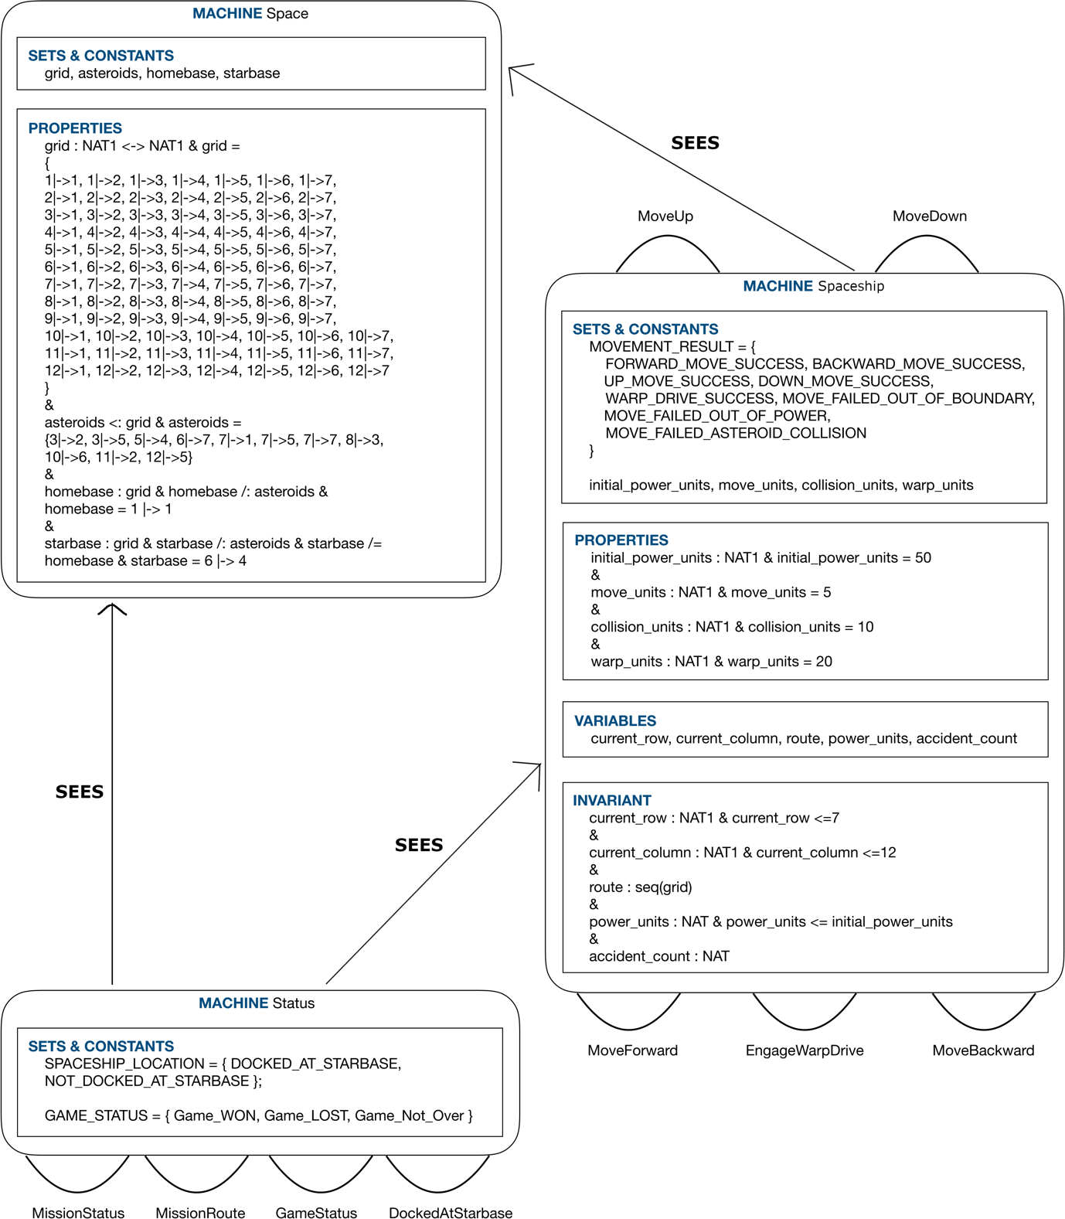

Figure **Error! No text of specified style in document.**. Structure diagram

# Explanation of state variables

|  |  |
| --- | --- |
| Variable | Explanation |
| current_row | Row ID of the Spaceship’s current location |
| current_column | Column ID of the Spaceship’s current location |
| route | Route of the spaceship (i.e. empty squares of the space grid, which were visited by the Spaceship) |
| power_units | Remaining amount of power units in the Spaceship |
| accident_count | Number of accidents that the Spaceship met with, meanwhile traveling around the space |

# Explanation of state invariants

|  |  |
| --- | --- |
| Invariant | Explanation |
| current_row : NAT1 | current_row belongs to the built-in typeset, natural numbers, starting with 1. Here, the lower limit of the variable is implicitly implied as 1. |
| current_row <= 7 | current_row can only hold up to the value 7 (upper limit) |
| current_column : NAT1 | current_column belongs to the built-in typeset, natural numbers, starting with 1. Here, the lower limit of the variable is implicitly implied as 1. |
| current_column <= 12 | current_column can only hold up to the value 12 (upper limit) |
| route : seq(grid) | route is defined as a sequence over the relation, “grid”. Reason for selecting a sequence is because we need to record the path which was travelled by the Spaceship in ascending order. |
| power_units : NAT | power_units belongs to the built-in typeset, natural numbers, starting with 1. Here, the lower limit of the variable is implicitly implied as 0. |
| power_units <= initial_power_units | power_units variable can’t hold a value greater than the value specified by the “initial_power_units” constant. (i.e. upper limit = initial_power_units) |
| accident_count : NAT | The Spaceship may not encounter with a single accident during the journey, hence natural numbers typeset, starting with 0 has been selected, over the natural numbers typeset staring with 1. |